10/09/2018

OLD TOWNE FRAME COMPANY

PROJECT UNDERSTANDING (RESUBMITTAL)

SUBMITTED BY: RYAN WOLFF, MITCH TULK, SAUD AI SAADOON, MATT ROLLINS

Table of Contents

1.1 Purpose of Project 3

1.2 Background Information/Existing Conditions 3

1.3 Technical Aspects of Project 4

1.4 Project Constraints 4

1.5 Project Challenges to be Overcome 4

1.6 Stakeholders 5

1.8 References 6

# Purpose of Project

The purpose of this project is to complete a site redesign for Old Town Frame Company in Cottonwood, Arizona. The project will involve survey field work, grading design,

drainage design (hydrology and hydraulics), ADA compliance design, geotechnical analysis, possible retaining wall design, and creation of construction plans.

# 1.2 Background Information/Existing Conditions

Per the team’s discussion with the client, Trevor Gottschalk of Old Town Frame Company, and the background history and research of the project site, the team has gathered the necessary information to scope the project. The client is the new occupant of the site at 107 S Candy Ln. Furthermore, the owner does not know for certain where the exact site boundaries are in relation to the surrounding properties. This will need to be determined via city records in the due diligence phase of the project.  Figure 1 and 2 below show the location of the site. This goal for the Old Town Frame Company is to develop a more efficient site plan that provides better property usage. The site is owned by Trevor Gottschalk, under parcel number 406-33-001C. As observed on Google Earth, the site appears to have little to no paving. There further exists a retaining wall that was believed to have been constructed more than 100 years ago. The client wants a parking lot redesign and the team has been instructed to ignore the actual pavement design aspect for this project.

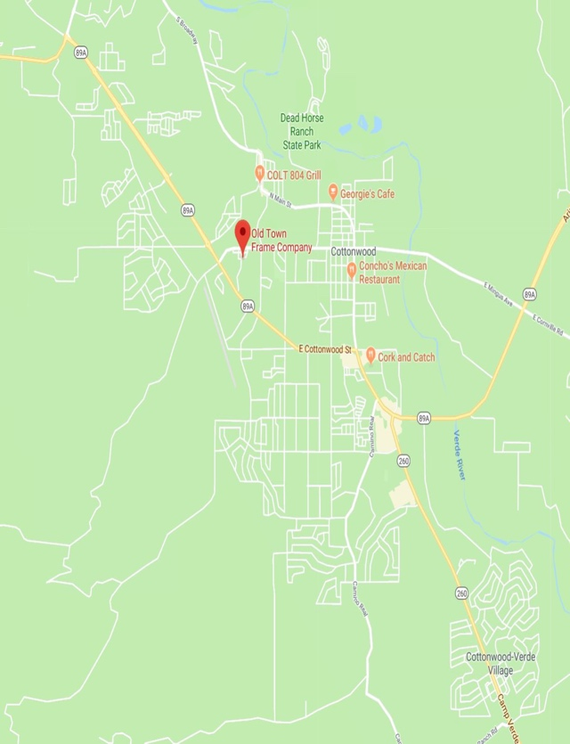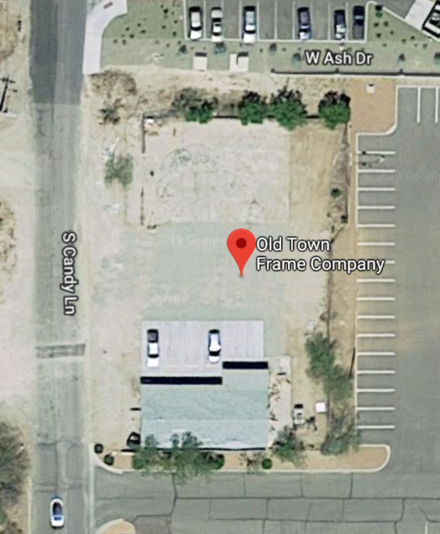

Figure . Project Location (via google maps) Figure . Aerial View of Site (via google earth)

# 1.3 Technical Aspects of Project

In the project, GPS surveying will be used to collect site data. The equipment will be provided by the school. The team will complete the GPS survey and upload the results to AutoCAD to create a surface. Once the surface is created it will be imported into Civil 3D and a topographic map will be created. This topographic map will be used for the existing grading design. The grading design is necessary to implement the data into the existing grading plan.

The drainage design will aid in reducing the possibility of water flooding on or around the site. Catch basins may be constructed to accommodate the runoff. The design created by the team will accommodate and utilize the existing.

Geotechnical analysis, specifically a CD and Direct Shear Test, will be conducted to determine the strength of soil and whether it fits the desired uses based on AASHTO and USCS soil standards (as well as USDA only if the client desires this classification). This will be done by taking soil samples from the site to gather moisture content information and perform a sieve analysis to perform the tests above.

# 1.4 Project Constraints

The project constraints will revolve around the schedule, cost and the scope as the limiting factors. This project will focus more on the research, testing, and design for the site development process rather than the actual construction phases. Both the timeline and the construction process dictate that construction will occur after the capstone class has ended. Other constraints will be identified as needed as the project progresses.

ADA compliance requires that public facilities and resources are accessible for people who are physically and mentally challenged [4]. This will be an important constraint specifically when redesigning the parking plan as the team will need to provide wheelchair access, handicap parking spots, etc.

# 1.5 Project Challenges to be Overcome

The most influential challenge to the project will be the timeline. Because this is a land development project, a small one, the team members and client will need to keep in mind that a typical project such as this can take up to a full year. Since there are only 6 months of class time to produce the same product, the most important aspects will be prioritized and executed. The team is also young students who have little to no experience in real world projects. There is also a lack of pre-existing data and the team will have to gather as much as possible as quickly as possible in the due diligence phase.

The engineering team is also aware that there will be another challenge with the retaining wall. The retaining wall may not be on the owner’s property which will be determined after consulting with City of Cottonwood. Determining the validity of a retaining wall redesign that coincides with new standards and codes since its original reconstruction will be a challenge for the team in the due diligence phase.

After observing the site on Google Earth, it has been determined that the team will need to add a pavement design to the current task list. The site appears to have little to no paving, as seen in figure 2 in section 1.1 of this document. The team would need to do a pavement design for the site, although the team has been instructed to ignore pavement design and instead provide a parking plan, another technical aspect that the team does not have experience with.

# 1.6 Stakeholders

The sole stakeholder of this project is the client: Old Towne Framing Company, a business in the City of Cottonwood, Yavapai County. The adjacent roadway is owned by Clemenceau Townsite LLC, according to Yavapai County Assessor website, but this should have no effect on the project because it is limited to Old Towne’s property. However, if drainage leaves the property to the roadway, the project will become subjected to possible erosion control liabilities per the adjacent company’s discretion.

# 1.8 References

[1] “Surveying Using GPS and Conclusion,” Datums | Intergovernmental Committee on Surveying and Mapping. [Online]. Available: https://www.icsm.gov.au/education/fundamentals-mapping/surveying-mapping/surveying-using-gps-and-conclusion. [Accessed: 08-Sep-2018].

[2] J. Tiner, “SunCam,” Fundamentals of Site Grading Design, 2014

[3] C. Hendrickson and T. Au, *Project management for construction: fundamental concepts for owners, engineers, architects, and builders*. Pittsburgh, Penn.: Carnegie Mellon University, 2008.

[4] *J. Demkin, The architect's handbook of professional practice; editor Joseph A. Demkin ; by the American Institute of Architects. New York: John Wiley, 2001.*

[5] J. Kent, *A Visual Synthesis of the ADA*